TYPE: Test

TASK 7: Digestion & Excretion Test (64 marks)
Students will complete a number of questions relating to the digestive and excretory systems. These questions will address specific content as well as analysis of second hand data. This task will be completed in one session under test conditions.

Time for the tasks (1 hour)
- 5 minutes reading time
- 55 minutes working time

What you need to do:

- Follow the instructions provided very carefully to complete the test.

- Draw any results in pencil and answer all questions given.

- It is your responsibility to organise your time effectively.

- There is to be no discussion between you or any of your class mates.

- No sharing of any equipment or answers at all.

Requirements for assessment | Due dates:
- Complete all questions | ___________________

DO NOT TURN THIS PAGE OVER UNTIL YOU ARE TOLD TO

STUDENT NAME: ANSWER KEY

TEACHER: Ms Caine YEAR: 11
Digestion and Excretion Test

PART A: Multiple choice questions.

Please mark your answers in the answer section provided and NOT on the questions.

- The series of muscular contractions that moves food along the digestive tract is called

- periosteum
- peristalsis
- pericardium
- perimysium

- Which of the following is not an excretory organ?

- intestine
- kidney
- skin
- lung

- Enzymes are involved in the process of

- ingestion
- egestion
- digestion
- elimination

- A vitamin is

- an inorganic compound required by the body in small amounts
- an inorganic compound required in large quantities by the body
- an organic compound required in small quantities by the body
- an organic compound required by the body in large amounts

- Urine is stored in the

- kidney
- bladder
- urethra
- ureter

- The flap of tissue that covers the trachea during swallowing is called the

- glottis
- epiglottis
- peristalsis
- larynx

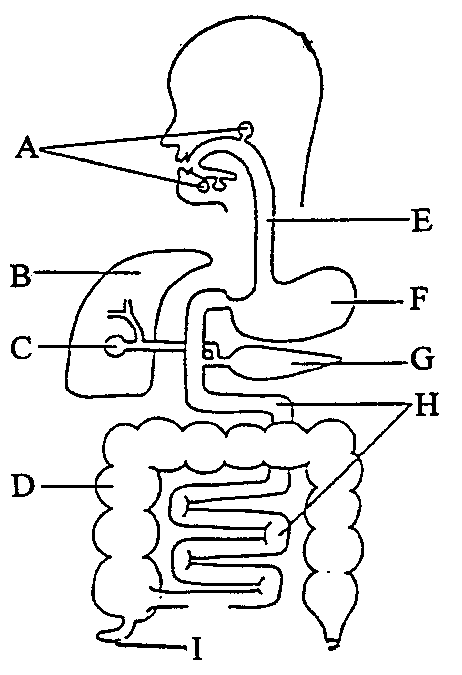

Use the diagram shown above to answer the next two questions.

- What is the name of the structure labelled C?

- pancreas
- salivary gland
- liver
- gall bladder

- Which structure is responsible for water absorption from undigested food?

- F
- G
- D
- I

- The removal of waste products through the anus is called

- excretion
- assimilation
- egestion
- elimination

- The table below indicates in which part of the digestive system a particular food is chemically digested.

Section of digestive tract | Food 1 | Food 2 | Food 3 | Food 4
Mouth | +
Stomach |  | +
Small intestine | + | + | +

Which of the foods shown above would most likely be a protein?

(a) food 1
(b) food 2
(c) food 3
(d) food 4

- The removal of metabolic wastes from the body is termed

- defaecation
- excretion
- elimination
- filtration

- The process of deamination occurs in the

- kidney
- pancreas
- stomach
- liver

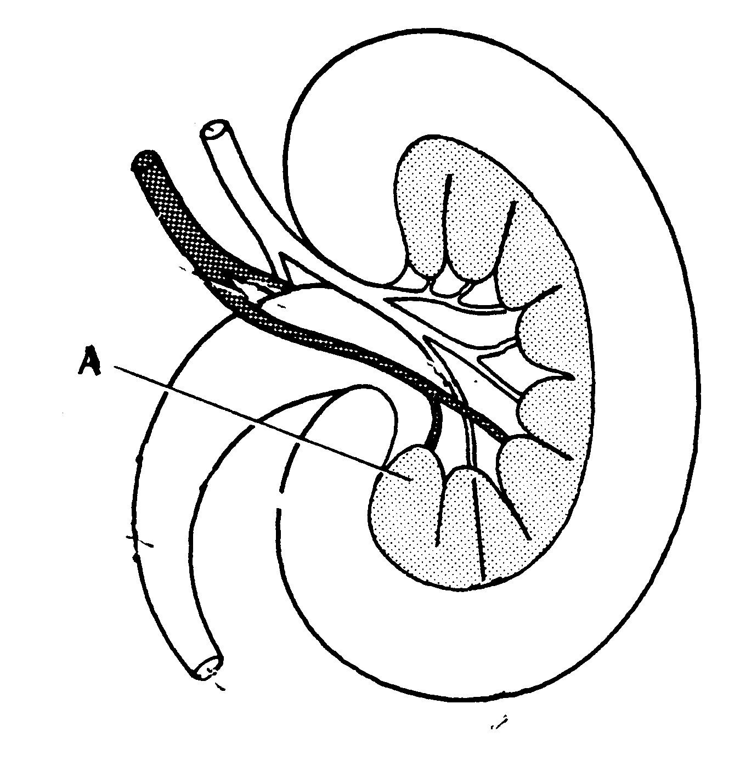

- On the diagram above the section labelled A is the

- medulla
- cortex
- calyx
- pelvis

- The movement of water from an area of high concentration to an area of low concentration through a semi permeable membrane is called?

- diffusion
- osmosis
- active transport
- filtration

- The projections found along the walls of the small intestine are called

- mucosa
- villi
- rennin
- ileum

- The only chemical digestion that occurs in the mouth is

- protein to polypeptides
- fats to fatty acids
- sugar to glucose
- starch to sugar

- The small intestine performs several important functions. Which of the following is not one of those functions?

- control of the amount of fluid and electrolytes that leave the body
- synthesis of vitamin K
- completion of digestion of each nutrient group
- absorption of the end products of digestion

- Which of the following reactions is catalysed by lipase?

- starch to maltose
- fats to fatty acids
- polypeptides to amino acids
- fatty acids to micelles

- During summer more fluid intake is required to overcome water loss through

- sweat
- breathing
- urine output
- faeces

- Although we cannot digest the bulk of cellulose we ingest, it is important to have
sufficient in the diet because it:

- contains an essential item of food.
- stimulates the stomach juices.
- prevents bacterial action.
- stimulates peristalsis.

- Absorption of digested food occurs largely in the:

- small intestine
- pancreas
- stomach
- large intestine

- Proteins are made up of units called:

- Amino acids
- Peptide bonds
- Glucose
- Monosaccharides

23. Bile is involved in the breakdown of fats. It is:

- produced in the gall bladder and stored in the liver
- produced in the liver and stored in the gall bladder
- produced in the pancreas and stored in the liver
- produced and stored liver

For questions 24 and 25, refer to the graph below showing the activity of two different enzymes that are found in the human digestive tract;
- Enzyme P is most likely to be:

  - an amylase
  - a lipase
  - a protease
  - it is impossible to say

- Which one of the following statements about P and Q is true?

  - Enzyme P is most active in an acidic medium and enzyme Q is most active in an alkaline medium
  - Enzyme Q will only be activated in one part of the digestive tract however enzyme P will be active all along the digestive tract
  - Enzyme Q will only break down carbohydrate however enzyme P will break down carbohydrate, protein and lipids
  - Enzyme P will be active over a wider pH range than enzyme Q

- Which of the following enzymes is correctly matched with the gland that secretes it, the substrate it acts on and the product made during chemical digestion?

 | Enzyme | Gland | Substrate | Product
(a) | Amylase | Pancreas | Starch | Glucose
(b) | Pepsin | Stomach | Dipeptides | Amino acids
(c) | Lipase | Stomach | Fats | Fatty acids and glycerol
(d) | Lactase | Pancreas | Lactose | monosaccharides

END OF MULTIPLE CHOICE QUESTION SECTION

PART B: Short Answer questions. (34 marks)

Please write your answers in the spaces provided on this sheet.

1. (a) Name the four tooth types and state in total how many of each are found in the mouth.

(i) INCISORS

TOTAL = 8
[2 Marks]
(ii) CANINES

TOTAL = 4
[2 Marks]
(iii) PREMOLARS

TOTAL = 8
[2 Marks]
(iv) MOLARS

TOTAL = 12
[2 Marks]

(b) What type of digestion do the teeth carry out?

MECHANICAL / PHYSICAL
[1 Mark]

(c) How is physical digestion different to chemical digestion?

BREAKS BIG PIECES INTO SMALLER PIECES (DECREASE PARTICLE SIZE) BUT CHEMICAL BONDS ARE NOT BROKEN
CHEMICAL DIGESTION ALTERS CHEMICAL STRUCTURE OF THE SUBSTANCE / BREAKS CHEMICAL BONDS
[2 Marks]

2. Name the part/s of the alimentary canal that is / are involved in;

- Secretion of enzymes
MOUTH / SALIVA, STOMACH, SMALL INTESTINE (PITS), PANCREAS
- Absorption of nutrients
SMALL INTESTINE, LARGE INTESTINE (VITAMINS/NUTRIENTS)
- Peristalsis
OESOPHAGUS, LARGE INTESTINE, small intestine
- Defecation
RECTUM (STORED), PUSHED THROUGH ANUS
[4 Marks]

3. The diagram below shows a single villus.
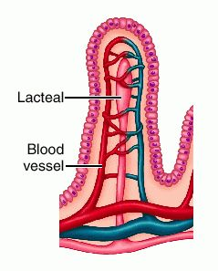
(iii)

(i)
(i)

(ii)

- Label the following parts.

(i) LACTEAL
(ii) CAPILLARY
(iii) MICROVILLI/Epithelium

[3 Marks]

- Where are villi found in the digestive system?

SMALL INTESTINE – WALLS OF – ALL ALONG THE LENGTH
[1 Mark]
- Why are the villi so small and so numerous?

TO INCREASE SURFACE AREA FOR ABSORPTION TO OCCUR
[1 Mark]

4. Describe the role played by each of the following structures in excretion.

- Lungs

EXCRETE CARBON DIOXIDE AND WATER VAPOUR
[1 Mark]

- Sweat glands

EXCRETE PERSPIRATION THROUGH SKIN PORES, NITROGENOUS WASTE (UREA), SALTS AND WATER
[1 Mark]

- Alimentary canal

REMOVES FOOD WASTE FROM DIGESTION, DEAD RED BLOOD CELLS, BILE SALTS
[1 Marks]

- Kidneys

FILTERS, REMOVES UREA, EXCESS SALT AND WATER
[2 Marks]

- Liver

PRODUCES UREA BY BREAKING DOWN AMINO ACIDS, REMOVE POISONS FROM THE BLOOD (ALCOHOL), STORES EXCESS SUGARS

[1 Mark]

5. Use the diagram of a kidney to fill in the missing labels.

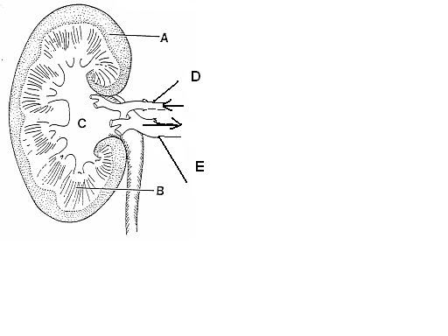

(a)
A CORTEX
B MEDULLA
C PELVIS
D RENAL ARTERY
E RENAL VEIN
[5 Marks]

- (i) What is the name of the structure that INITIALLY filters the blood in the kidney?
BOWMAN’S CAPSULE / GLOMERULAR CAPSULE
[1 Mark]
(ii) The tube leading from the bladder to the outside is called?
URETHRA
[1 Mark]
(iii) What happens to the urine output if the body fluids contain less water?
DECREASES
[1 Mark]

PART C: Extended Response Answer. (12 marks)

Please write your answers in the spaces provided on this sheet.

1. It’s lunchtime and you go out to have lunch in the shade of a tree on the lawn with some friends. You open your lunch box and find the ham and cheese sandwich you made at home last night.

Using dot points: trace the digestive journey of a carbon atom in the bread of your sandwich from when you take a bite, through the alimentary canal, to being absorbed into the blood stream, used for energy in a muscle cell and being excreted via the lungs.

The carbon atom is part of a starch molecule – in bread (1), eventually it will be part of a glucose molecule (1)
Path it follows – roughly -
Mouth – chemical; mechanical; saliva (1)
Esophagus – peristalsis (1)
Sphincter to stomach (1)
Stomach – muscular walls - churning; protein digestion; acidic ( 1 (muscular walls and churning) + 1 )
Pyloric Sphincter – release chime into small intestine (1)
Duodenum
Small intestine – villi (1), intestinal juices – enzymes from pancreas(1) ; bile from liver – emulsify fats/lipids(1)
    - Absorb nutrients into villi, (1) then to blood capillaries around the lacteal(1)
Lacteal absorbs products of lipid breakdown (1)
Carbon atom enters the blood stream as part of a glucose molecule (1)

Cellular respiration – glucose + oxygen = H₂O + CO₂ (1) C atom ends up in carbon dioxide

CO₂ Carried in blood as –(1) CO_{2,} and it’s forms – carbaminohaemoglobin (1); bicarbonate ions

Gas exchange at alveoli surface (1) – diffusion –(1) concentration of CO₂ in alveoli
Low (1) compared to blood ~ high, hence CO₂ moves from capillaries to alveoli and then
is exhaled from the lungs (1) A description of exhalation …(max of 2 marks)

TOTAL = 12 of the points listed above.

END OF TEST

